- Create a file and add executable permission to all users (user, group, others)
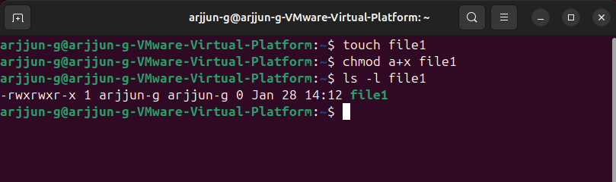
- Create a file and remove write permission only for group
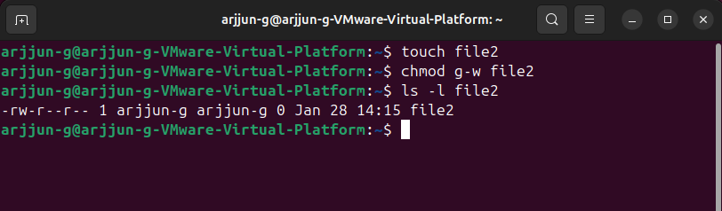
- Create a file in dir1/dir2/ and create a softlink inside dir1
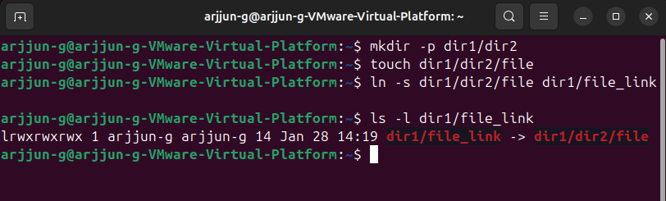

- Use ps with options to display all active processes
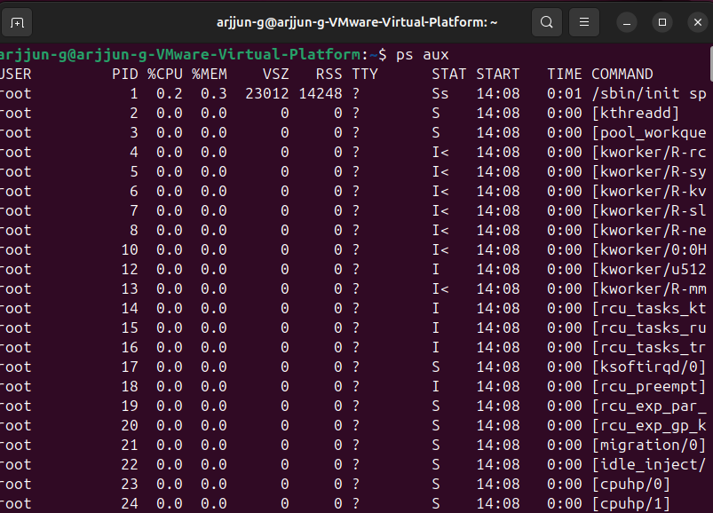
- Create 3 files in dir1 and redirect ls output sorted by timestamp to a file
